**0DMP PROJECT:**

**3D Ad of a Coding Company: griptz**

**Duration: 30 to 45 Sec**

**Voiceover: Use AI**

**Webpages design**

**Dark Theme and should be Feel Realistic.**

**No Character Needed.**

**Write Formal Script and Storyboard in next meeting.**

**Part I: Web Development**

Starts in a room which has a pc open, the camera zooms into the screen, then the browser open and a website is animated starting with wireframe of the website to main website. And 5 different websites land page are shown and animated.

Title card ‘Web development’ appears on the wall behind the monitor as the camera zoom out a bit.

Voice over: Your website is your digital home. We start with a blank canvas,

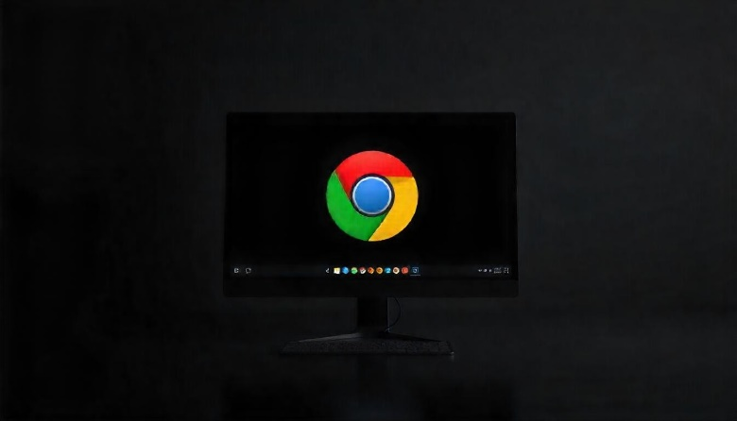

**Part II: Mobile App Development**

There is mobile phone kept in a stand just next to pc on the table. The phone animates and comes to centre of the screen. Apps’s icon, buttons start to animate inside the phone and a new app is formed. The five different app’s landing page is shown and animated.

Title card ‘Mobile app development’ appears on the wall behind the phone as the camera zoom out a bit.

Voiceover:

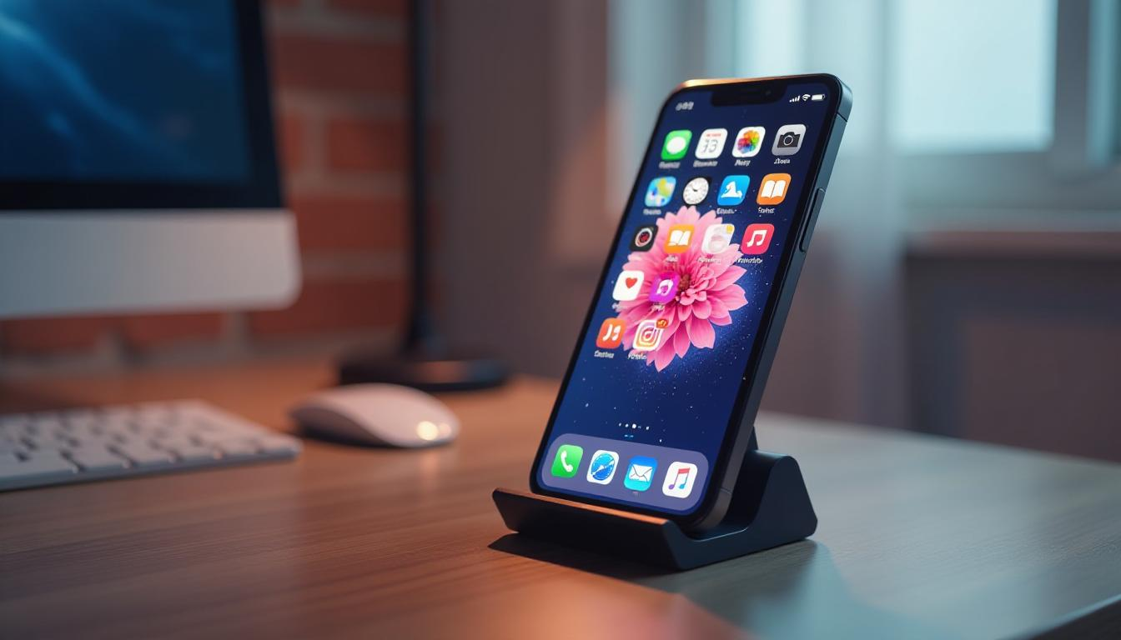

**Part III: Market Survey**

The camera pans to a tablet on the desk. The tablet screen lights up, displaying a market survey dashboard. Shows charts, bar graphs, and pie charts animating on the screen, representing survey data. (charts in 3D if possible).

Title card ‘Market Survey’ appears on the desk.

Voiceover:

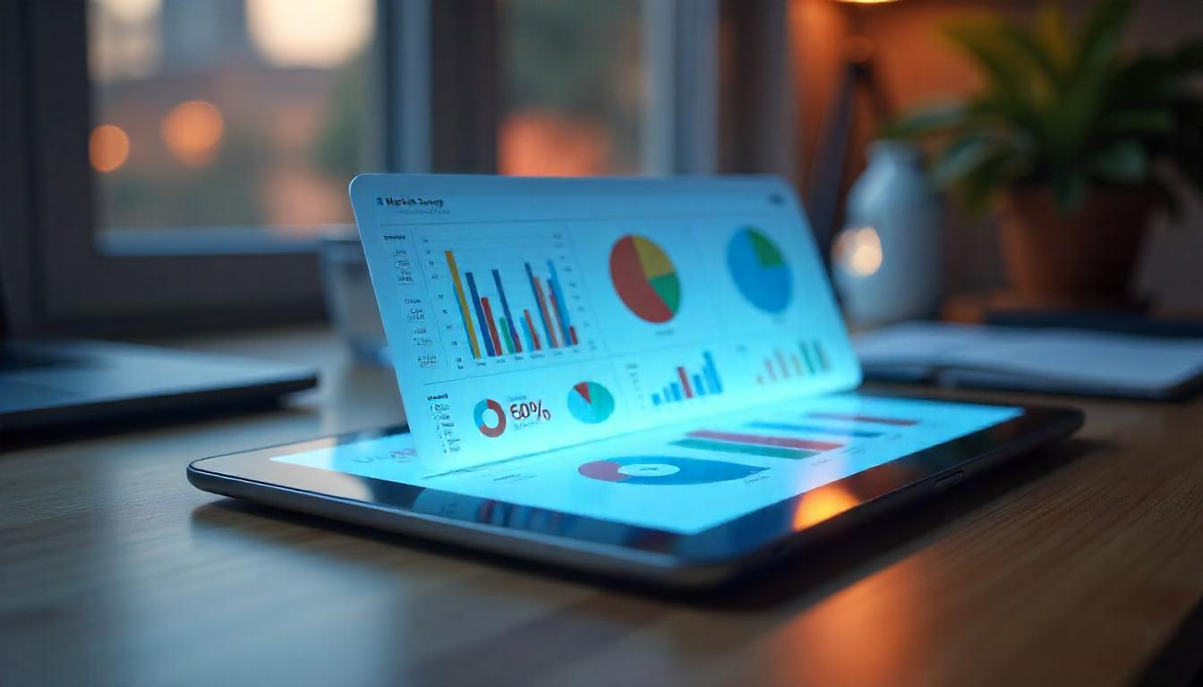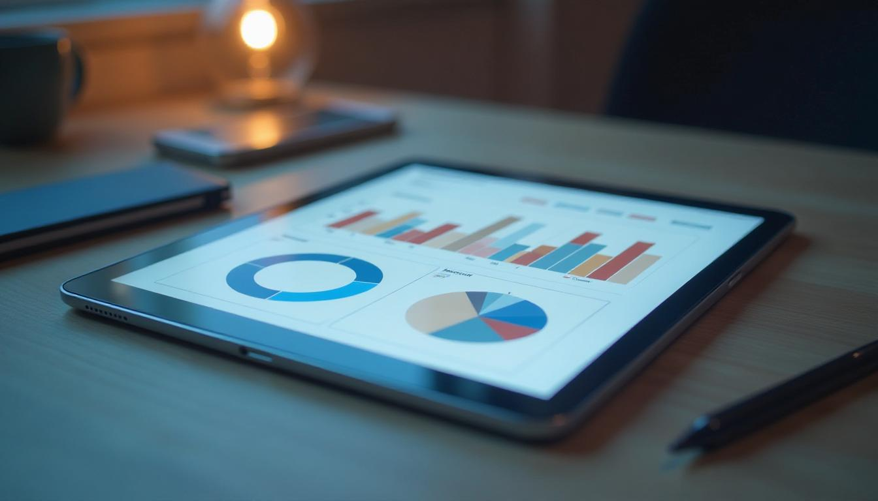

**Part IV: Software Maintenance**

The camera moves back to the desktop, with an alert notification about software maintenance popping up on the screen. The alert changes into animation of a maintenance update. The system is updated automatically, shown by gears moving and fixing the problems.

Voiceover:

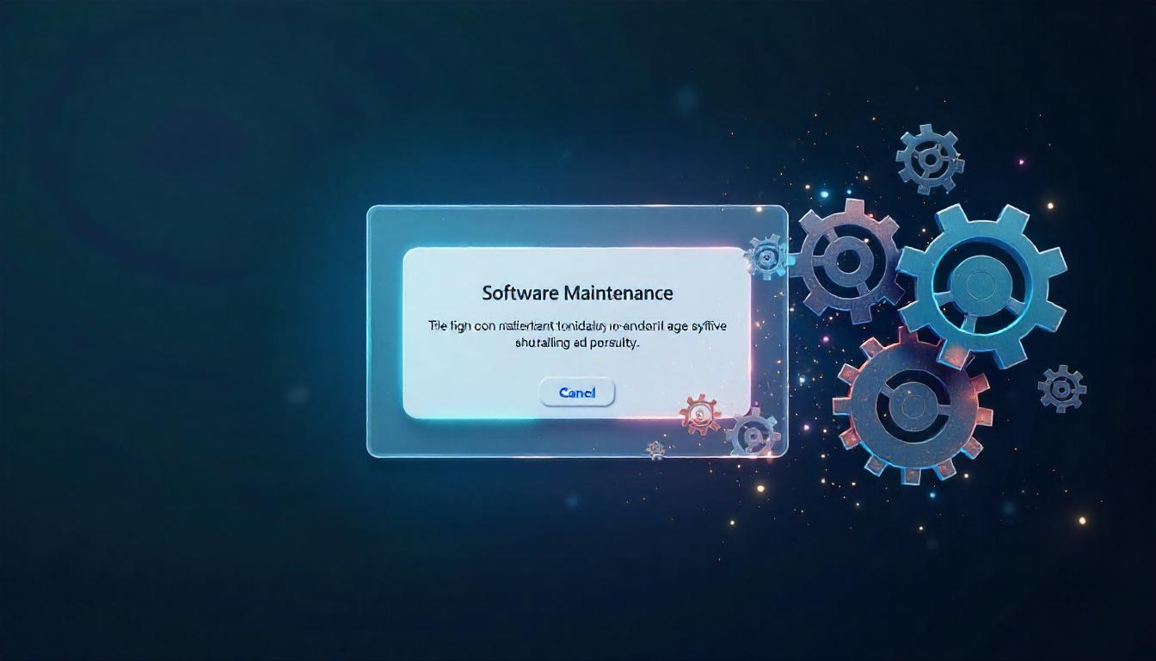

**Part V: Logo Animation**